A Biography of Jules Regnault
The Father of the Modern Financial Theory

Franck Jovanovic‡

In 2001, Philippe Le Gall and I highlighted Jules Regnault’s Calcul des chances et philosophie de la bourse in this journal. With his book, published in 1863, Jules Regnault would eliminate a theoretical gap: he would create a “stock exchange science” based on statistical and probabilistic analysis. He is the first to construct a modern theory of stock price changes and to represent them by a random walk model, which he successful validated. His analysis was strongly different from that found in other books published in his time. In fact, other books gave, in the better cases, a description of financial markets, and generally they gave only “recipes” for how to become rich. More precisely, until the 20th century, Jules Regnault’s quantitative and theoretical approach had no equivalent in other countries. Thus, his book, his only publication, is the first work of modern financial theory. The 19th-century French academic context was however prepared to receive neither Jules’ attempt nor those of the French actuary Henri Lefèvre who published his works between 1870 and 1885. Jules Regnault’s attempt led neither to scientific acceptance for this discipline nor to the creation of an academic community. Nevertheless, although there was no collective research dynamics throughout the second part of the 19th-century, modern financial theory was born in 1863 with this book.
Several recent works present Regnault publishing context. However, until now, only very few biographical elements on this author have been known. Thus, it is difficult to appreciate his publication in its own historical context, to identify its origins and to understand its influence. This article fills this gap. I expose the major elements of my investigation in two parts. The first one presents a biography of Jules Regnault. The second part analyses the influence of the Calcul des chances et philosophie de la bourse.

1. Jules Regnault

Jules Augustin Frédéric Regnault was born on February 1, 1834 in Béthencourt, département du Nord, France.

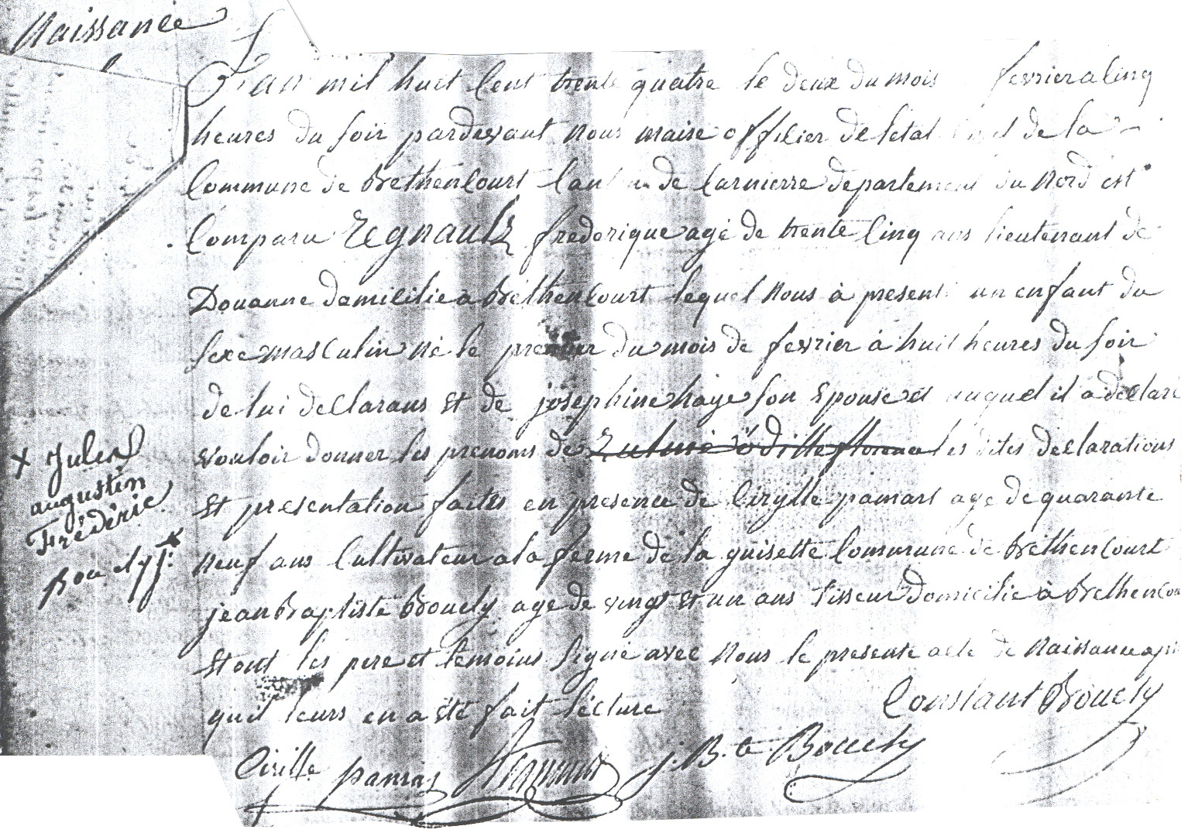

L'an mil huit cent trente quatre le deux du mois de février à cinq heures du soir par devant nous maire officier de l’état civil de la commune de Béthencourt canton de Carnierre Département du Nord est comparu Regnault frédérique âgé de trente cinq ans lieutenant de Douane domicilié à Béthencourt lequel nous a présenté un enfant de sexe masculin né le premier du mois de février à huit heures du soir de lui déclarant et de Joséphine Haye son épouse auquel il a déclaré vouloir donner les prénoms de Jules Augustin Frédéric. Les dites déclarations et présentation faites en présence de Cirylle Pamart âgé de quarante neuf ans cultivateur à la ferme de la guisette commune de Béthencourt Jean Baptiste Boucly âgé de vingt et un ans tisseur domicilié à Béthencourt et ont les père et témoins signé avec nous le présent acte de naissance après qu’il leurs en a été fait lecture.

On February 2, 1834 at 5 p.m., Regnault Frédérique, 35 years old, appeared before us the Mayor of commune de Béthencourt, canton de Carnierre, département du Nord. He is a Customs lieutenant living in Béthencourt. He presented to us a male child born on February 1, at 8 p.m. to him and his wife, Joséphine Haye. He declared that he wants to give him the first names of Jules Augustin Frédéric […].

His father, Augustin Frédéric Regnault, was a Customs officer. His paternal grandfather, Jean Baptiste François Regnault, was a bailiff, and his maternal grandfather, Louis Haye, a manufacturer and a property owner.

Regnault Family Genealogical Tree

Jean Baptiste
Regnault
( ?- ?)
Marie
Simard
( ?- ?)
Louis
Haye
( ?- ?)
Bernardine
Laude
( ?- ?)

Augustin Frédéric
Regnault
(1799-1846)
Joséphine
Haye
(1803-1895)

Odilon
Regnault
(1827-1871)
Odille
Regnault
(1829-1832)
Jules
Regnault
(1834-1894)
Delphine
Regnault-Lescuyer
(1837-1927)

During the first years of his life, Jules Regnault lived in the département du Nord where his father worked. His family moved often but always stayed near Cambrai. When his father died on January 16, 1846, in Paris, Jules was 12 years old. After this death, his family moved to Brussels, where Odilon, Jules’ brother, became a writer and a student at the Université Libre de Bruxelles in advanced mathematics. Although he was registered for several years, Odilon did not graduate from this University. However, we do not know of Jules’ education, but the move to Brussels suggests that he was educated in this city. I must emphasise two points. First, Jules was not the only member of his family to be interested in mathematics. In addition to his brother, one of his cousins, Albert Picard, was a teacher of mathematics at high school in Tours. Second, at this time, Jules’ family was not rich. His father bequeathed no fortune. Thus, Odilon was except from serving in the military service and from paying his University registration. When Jules Regnault arrived in Brussels, he probably benefited from the law of June 1st, 1850, which created the foundations of the high school public education. However, the modest financial resources of his family could explain that either he was not an undergraduate nor that he did not graduate.
Whatever Jules Regnault’s educational level, one point that contributes to understanding the origins of his work can be recalled: at this time in Belgium, education was completely reorganised, in particular under Adolphe Quételet’s (1796-1874) influence. After the doctorate he got from Ghent University in 1819, Quételet obtained the chair of elementary mathematics and afterwards the chair of advanced mathematics at the Athenaeum of Brussels. His first mathematical work led him to be elected to the Accademie Royale de Belgique that he managed later on. From 1824, he lectured in several scientific fields at the military college and the Museum. He also participated in the creation of the first public office of statistics, several scientific journals and the Brussels’ observatory. He also published several handbooks in which he exposed the principles of his “social physics” and his method for applying the theory of probability to social and moral sciences. Quételet had a great influence and audience in the country. His positions led him to reform both natural education and research. One must remember that, before the 1820s, this country was an intellectual desert; Quételet gave a new impetus to its intellectual life. His publications and courses exerted a decisive influence on the new generation of Belgian students as well as the new Belgian researchers. This setting had a significant influence on Jules Regnault, because it is most probably during his education in Belgium that he elaborated the main principles of his financial theory.
Quételet’s influence on Jules Regnault’s thought is undeniable. We know that Quételet was the first to concretise the Condorcet and Laplace program, which aimed at applying the theory of probability to the social universe. With his book, Jules Regnault followed exactly this program. He defended the use of mathematics and statistics to study human and social facts. From Quételet, he took the tools, the hypothesis, the method, the worldview as well as the way to expose the results –for example, the limited presentation of mathematical calculations as Quételet suggested in his Lettres sur la théorie des probabilités appliquée aux sciences morales et politiques. One also notes the closeness of the moral positions of these two authors, for instance the importance of labour value or individual prudence. Thus, the Calcul des chances et philosophie de la bourse must be regarded as an extension of the research program of Condorcet, Laplace and Quételet to a new field: the determination of “scientific laws” that rule financial markets.
At the beginning of the 1860s, Jules Regnault and his brother left Brussels for Paris. Jules was 28 years old when his name appeared in the electoral lists of the 9th district of Paris, in 1862. Thus, even if we do not exactly know when he moved to Paris, because several electoral lists were lost, he probability arrived around 1862. Between 1862 and 1866, it seems that he shared an apartment with his brother, Odilon, at the 13 rue Neuve-des-Martyrs (which is nowadays rue Manuel, the numeration of the street also changed). From 1862 until his death in 1894, he always lived in Paris. He lived only in the 9th and 10th districts and always near the Paris Stock Exchange. This closeness is not a coincidence: Jules and his brother were brokers [employés d’un agent de change] in the Paris Stock Exchange. For a full understanding of the origin of the Calcul des chances et philosophie de la bourse, it must be remembered that French financial markets passed out of a strong bull period, which was the result of the economic growth that occurred during the first years of the Second Empire. However, from 1857 to 1874, after this bull period, the Paris Stock Exchange knew a crisis period with a high volatility in stock prices. This price rise and this crisis volatility provoked many debates and reforms, in particular during the 1860s. Through his job, Jules was obviously concerned with these questions.
In all probability, when Jules and Odilon arrived in Paris, their financial resources were low because they lived in one (or two) garret room(s), for which no tax had to be paid. From 1866 onwards, their resources were more important. They could rent two separate flats on rue de Belzunce: Jules moved to the number 20 and Odilon to the number 12. Odilon married Eliza Damoye (1830-1876) on April 9, 1870 and he died about one year later, on September 10, 1871. Because he had no children, his heirs were his wife, his mother, his sister and his brother. The declared amount of the inheritance was very low (442.64 francs, that is around 1,500 euros 2004) and it was mainly constituted of bonds. Eliza died a little over four years later, on June 18, 1876. In her testament, Jules was her only heir. The declared amount of this inheritance is also very low (624 francs, that is around 2,400 euros 2004). This amount shows that Odilon and his wife had few financial resources.
Jules lived at 20 rue de Belzunce until 1875, then he moved to 17 rue de Montyon where he stayed until 1880. In 1881, he stopped being a broker and became a rentier. Jules moved into a new flat, 13 rue de Maubeuge (Paris 10th district) in which he lived for five years and then, in 1886, he lived at 83 rue de Maubeuge. Jules lived there until 1894, when he moved to 25 rue de Rocroy where he lived with his mother and his sister, both widows. These 13 years correspond to a very easy financial period for him. His flats had large area and appurtenances for servants. In fact, Jules had several servants: a domestic, a carriage-man and a gardener. From 1887 to his death, he rented a stable and a garage for his three carriages and three horses, 140 boulevard Magenta. At that address there was also a room for his carriage-man. Although Jules always rented his Parisian flats, he bought a large site in Saint-Gratien (near Paris) for 45,000 francs (171,500 euros 2004) in 1887. He expanded this side in 1887 with the buying of a second one next to it for 6,100 francs (23,250 euros 2004). Then, in 1888 and 1893, Jules bought two sites in Enghien-les-Bains (near Paris) for a total amount of 47,928 francs (182,500 euros 2004). He built two houses on them. These properties were his summerhouses. Finally, in 1894, Jules bought a perpetual grant of grave (concession perpétuelle) in the Père Lachaise cemetery. During this period, he also lent important amounts to several persons for more than 65,000 francs total (that is around 248,000 euros 2004).
Jules died on December 9, 1894.

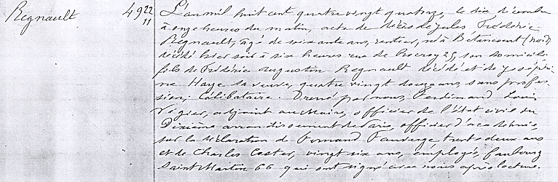

L'an mil huit cent quatre vingt quatorze, le dix décembre à onze heures du matin, acte de décès de Jules Frédéric Regnault, âgé de soixante ans, rentier, né à Bétancourt (nord) décédé hier soir à six heures rue de Rocroy 25, son domicile, fils de Frédéric Augustin Regnault décédé et de Joséphine Haye sa veuve, quatre vingt douze ans, sans profession, célibataire. Donné par nous, Ferdinand Louis Vigier, adjoint au Maire, officier de l'état civil du Dixième arrondissement de Paris, officier d’académie, sur la déclaration de Fernand Fauverge, trente deux ans et de Charles Caster, vingt six ans, employés, faubourg saint Martin 66 qui ont signé avec nous après lecture.

On December 10, 1894, at 11 a.m., certificate of death of Jules Frédéric Regnault, 60 years old, rentier, born in Béthencourt (département du Nord), deceased yesterday at 6 p.m. in his house, 25 rue de Rocroy, son of Frédéric Augustin Regnault, deceased, and Joséphine Haye, his widow, 92 years old, without profession, single […].

His body was buried in his vault in the Père Lachaise cemetery. When he died, his fortune was estimated at 1,026,510.03 francs (that is more than 3.8 million euros 2004). Jules never married; consequently, he had no direct heir. He left a testament at a Parisian lawyer. His testament gives a good idea of his financial means and his lifestyle.

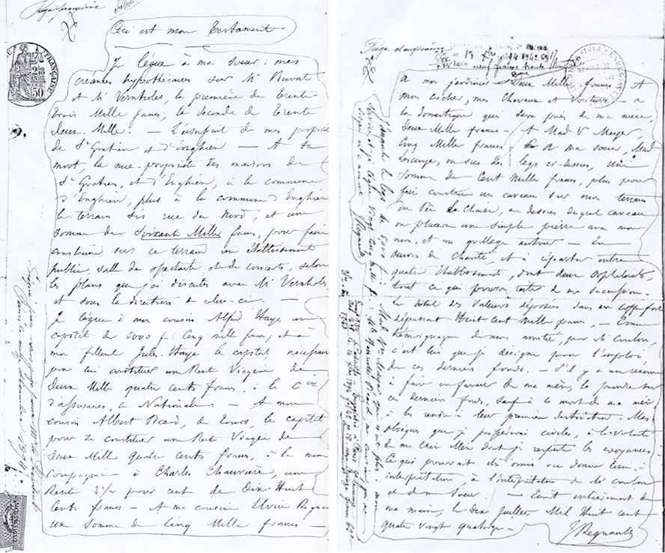

Ceci est mon testament.
Je lègue à ma sœur : mes créances hypothécaires sur M. Buvat et Vernholes, la première de trente trois mille francs, la seconde de trente deux mille. L’usufruit de mes propriétés de St Gratien et d’Enghien. A sa mort, la nue propriété des maisons de St Gratien et d’Enghien à la commune d’Enghien, plus à la commune d’Enghien le terrain sis rue du Nord et une somme de soixante mille francs pour faire construire sur ce terrain un établissement public, salle de spectacle et de concerts, selon les plans que j’ai discutés avec M. Vernholes et sous la direction de celui-ci.
Je lègue à mon cousin Alfred Haye un capital de 5000 frs, cinq mille francs, et à mon filleul Jules Haye, le capital nécessaire pour lui constituer une rente viagère de deux mille quatre cents francs à la Cie. d’assurance la Nationale. A mon cousin Albert Picard, de Tours, le capital pour se constituer une rente viagère de deux mille quatre cents francs à la même compagnie. A Charles Chaumière une rente 3^{1/2} pour cent de dix huit cents francs. A ma cousine Elvire Regnault, une somme de cinq mille francs. A mon jardinier deux mille francs, à mon cocher, mes chevaux et mes voitures, à la domestique qui sera près de ma mère, deux mille francs. A Mad. V. [madame veuve] Meyer, cinq mille francs, à ma sœur Mad. [madame] Lescuyer, en sus du legs ci-dessus, une somme de cent mille francs, plus pour faire construire un caveau sur mon terrain du Père Lachaise au-dessus duquel caveau on placera une simple pierre avec mon nom et un grillage autour. En œuvre de charité, et à répartir entre quatre établissements, dont deux orphelinats, tout ce qui pourra rester de ma succession. Le total des valeurs déposées dans mon coffre-fort dépassant huit cent mille francs. Comme témoignage de mon amitié pour M. Coulon c’est lui que je désigne pour l’emploi de ces derniers fonds. S’il y a une réserve à faire en faveur de ma mère, la prendre sur ces derniers fonds, sauf à la mort de ma mère [à] les rendre à leur première destination. Mes obsèques, que je préfèrerais civiles, à la volonté de ma chère mère dont je respecte les croyances. Ce qui pourrait être omis ou donner lieu à interprétations à l’intention de M. Coulon et de ma sœur. Ecrit entièrement de ma main, le dix juillet mil huit cent quatre vingt quatorze.
J. Regnault
En marge, il est écrit : J’annule le legs de 5000 frs à madame veuve Mayer qui n’est plus à mon service, et je lègue vingt cinq mille francs à mademoiselle Henriette Picard, ma cousine qui me soigne en ce moment.
J. Regnault

This is my testament,
I bequeath to my sister: my loan accounts to Sirs Buvat (33,000 francs) and Vernholes (32,000 francs); the usufruct of my St Gratien and Enghien properties. At her death, the bare ownership of St Gratien and Enghien houses [passes] to the Enghien Commune, plus to the Commune of Enghien a site on the rue du Nord and 60,000 francs to build on this site a public establishment, entertainment and concerts building. It will be built under the direction of Sir Vernholes and according to the plan that I discussed with him.
I bequeath to my cousin Alfred Haye, 5,000 francs and to my godson Jules Haye, the necessary capital to establish for him a 2,400 franc life annuity at the National Insurance Company; to my cousin Albert Picard of Tours, an amount for him to establish a 2,400 franc life annuity at the same company. To Charles Chaumière one 1,800 franc rente 3^{1/2} [the French bond]. To my cousin Elvire Regnault, 5,000 francs. To my gardener, 2,000 francs; to my carriage-man, my horses and my carriages; to my domestic who will stay with my mother, 2,000 francs; to the widow Madame Meyer, 5,000 francs; to my sister Madam Lescuyer, in addition to the bequest above, 100,000 francs, plus the necessary amount to build a burial vault on my plot in the Père Lachaise cemetery. On top of it is to be placed a bare stone with my name on it, and a fence should be set around it. Any remaining amount is to be shared between four charitable institutions including two orphanages. The whole securities amount deposited in my safe-deposit box is worth more than 800,000 francs. In recognition of my friendship for Sir Coulon, I designate him to use these last funds. If more funds are necessary for my mother to take them from the 800,000 francs, and at her death to return them to their first destination. My funeral, which I would prefer to be civil, will be according to the will of my dear mother whose beliefs I respect. Any omissions or anything that could give rise to interpretation should be referred to Sir Coulon and my sister. Fully written by my own hand, July 10th, 1894.
J. Regnault
In the margin: I cancel the 5,000 franc bequest to the widow Madam Mayer who is no longer in my service, and I bequeath 25,000 francs to Miss Henriette Picard, my cousin who cares for me at this time.
J. Regnault

The inventory of Regnault’s goods shows that the most important part of his fortune was invested in bonds (around 706,500 francs, that is around 70% of his fortune), in particular in the French 3.5% rente (166,216.80 francs), and in shares (around 104,565 francs, that is about 10%). This inventory and the previous information on Jules’ family financial resources suggest that he applied financial theory to establish a fortune. According to the Calcul des chances et philosophie de la bourse, and as Jovanovic and Le Gall (2001) explain, the only valid investment for Jules Regnault must be bonds, which is precisely what his inventory shows. It can be assumed that Jules Regnault needed time to buy enough bonds to live form income coupons. This might explain why he became a rentier and bought real estate only at the end of his life. Moreover, one should note a change in tax law. Before 1872, properties and their income had been taxed, but not securities and their income. After 1872, all of them were taxed. This fiscal change could have led Jules to modify his wealth by choosing a better balance between securities and real estates.
In his testament, he bequeathed the most important part of his fortune to his sister (around 624,980 francs, that is 61%) and an important part to the city of Enghien-les-Bains (191,000 francs, that is 19%). The rest was shared between his mother, his cousins, and his servants. His bequest to Enghien-les-Bains included all his properties:
- his 8478 m² site in Saint-Gratien, avenue de Soisy (nowadays, rue Danièle-Casanova), which was successively changed to a football site and then to a tennis court;
- his house at 1 bis avenue de Ceinture, which had a garden of 792 m² contiguous to the casino. In 1958, this house was sold to the Société d’exploitation des Eaux et Thermes. Today, it is the administration of the Casino d’Enghien-les-bains;
- his site at the junction of avenue de Ceinture and rue du Nord (nowadays rue de la Libération). In 1896, the first entertainment hall of Enghien-les-Bains was built on it.
At Jules Regnault’s time, the city of Enghien-les-Bains was very new. Thus, this bequest was very important for it. Grateful for his bequest, the city gave Jules Regnault’s name to one of its streets.

2. On the influence of the Calcul des chances et philosophie de la bourse

We have seen that Jules Regnault and his brother were brokers, i.e. they worked for an agent de change. At this time, the Paris Stock Exchange had only 60 agents de change. It was not easy to become agents de change because such offices were very expensive, and generally the agents de change had their own successors. The agents de change were public officers who had the monopoly of transactions on the stock exchange. They employed many persons. Because Jules was a broker, we can believe that other brokers and financial analysts of the second half of the 19th century read his book or knew of his ideas. It was probably in this way that Jules Regnault's ideas influenced Louis Bachelier. As Bachelier explains (1912: 293), before 1900 and probably since 1895 (Courtault et alii 2002: 22), he was interested in finance. As I explained in Jovanovic (2000), Bachelier used Regnault’s hypotheses and presented them in the same order, although he referred to no financial work. The influence of Regnault’s book through brokers probably continued after 1900, because Maurice Gherardt used the work in his book, Le gain mathématique à la bourse, published in 1910. This speculator was interested in the statistics and calculus of probabilities and their applications to games of chance. He extended Regnault’s calculus and associated it to Bachelier’s thesis.
We also know that French actuaries used the Calcul des chances et philosophie de la bourse. Emile Dormoy referred to it in his 1872 and 1873 articles. Let me remind the reader that, in France, during the second half of the 19th century, actuaries and French econo-engineers were the main supporters of the use of mathematics in the social sciences, in particular in economics. They played an important role in the creation and the diffusion of the mathematical and statistical methods in economics. It is well known that Léon Walras found some supports in the French actuary community. Moreover, Henri Lefèvre, whom I mentioned above, who also tried to create a Stock Exchange science, was a French actuary too.
Finally, Jules’ book had an international diffusion, although it is not easy to evaluate its impact. The British Library, the Libraries of Congress (in the United-States), of the University of Toronto and of the Katholieke Universiteit Leuven bought his book. This international diffusion reminds us that Louis Bachelier’s works, which, until the 1960s, were rather unknown in France, were well known in the United-States, the United-Kingdom, and Russia. In the case of Regnault, however his book does not seem to be quoted outside France.
To have an idea of Regnault’s book’s influence, we will find below, classified chronologically, the libraries which have the Calcul des chances et philosophie de la bourse and the authors who mention it.

Libraries which have a copy of the Calcul des chances et philosophie de la bourse:
- the Bibliothèque Nationale de France;
- the British Library, received in the second part of March 1864;
- the Library of Congress (U.S.A.), received in 1884 (classified as a financial/gambling book);
- the Library of the University of Toronto, received in 1892 (classified as a probability book);
- the Library of the Katholieke Universiteit Leuven.

Books which reference Regnault’s book:
Laurent, Hermann (1873). Traité du Calcul des Probabilités. Paris: Gauthier-Villars.
Laurent, Hermann (1893) Théorie des jeux de hasard. Paris: Gauthier-Villars.
Piéron, Henri et Nicolas Vaschide (1903). Les Applications du Calcul des Probabilités. In L’Enseignement Mathématique, 5ème année (1-2): 1-44.
Barriol, Alfred (1908). Théorie et pratique des opérations financières. Paris: Octave Doin.
Keynes, John M. (1921). A Treatise on Probability. London: MacMillan.

Articles and books which use the Calcul des chances et philosophie de la bourse:
Dormoy, Emile (1872-1873). Théorie mathématique des jeux de hasard. Journal des Actuaires Français, tome 1: 120-46 and 232-57, and tome 2: 38-57.
Gherardt, Maurice (1910). Le gain mathématique à la Bourse. Paris: Charles Amat.
Massebeuf, Alexandre (1923). Des marchés à primes dans les bourses de valeurs (Paris - Londres - Berlin). Paris: Garnier frères.
Laferrière, Julien (1951). La loi juridique et la loi scientifique de la Bourse. Unpublished. Paris: Cujas Library (call number: MS 196).

Notice finally that there is a mistake in the Grand dictionnaire universel du XIXe siècle published by Pierre Larousse. In the Jules Regnault bibliographical note, he wrote “Regnault (Jules), French learned, dead in 1866”. This note attributes several books to Jules. However, with the exception of the Calcul des chances et philosophie de la bourse, all the other books were written by Jean-Joseph Regnault (1797-1863) who signed some of his books “J. Regnault”. This signature can explain the mistake. However, these two authors have no family relationship. The Catalogue général de la librairie française published in 1871 made the same mistake. We also find it in some web pages and in the catalogues of the British Library, the Library of Congress, and the Library of the University of Toronto.

Resources used
Archives Crédit Lyonnais.
Archives départementales des Ardennes: Certificates issued by the Registry Office.
Archives départementales de l’Aube: Certificates issued by the Registry Office.
Archives départementales de la Marne: Certificates issued by the Registry Office.
Archives départementales du Nord: Certificates issued by the Registry Office, military registration tables, bursaries and scholarship, Business school student lists.
Archives départementales de l’Oise: Certificates issued by the Registry Office.
Archives départementales du Val d’Oise: Certificates issued by the Registry Office, Land register (Cadastre), donations and bequests, minutes notariales (Notarial Inventory records).
Archives économiques et financières du Ministère des finances et de l’industrie.
Archives Nationales: minutes notariales (Notarial Inventory records).
Archives de la mairie d’Enghien-les-bains : Regnault’s bequest.
Archives de la ville de Bruxelles: Certificates issued by the Registry Office, Land register (Cadastre).
Archives de la ville de Paris: Certificates issued by the Registry Office, electoral lists, Land register (Cadastre), direct taxes and “patentes”, estate, military registration tables.
Archives of the Université catholique de Louvain: students graduation lists.
Archives of the Université Libre de Bruxelles: students graduation lists.
Archives of the University of Ghent: student lists.
Centre des archives contemporaines: minutes notariales (Notarial Inventory records).
Cimetière du père Lachaise: perpetual grant of grave file.

References
Bachelier, Louis (1912). Calcul des probabilités. Paris: Gauthier-Villars.
Bouvier, Jean and Jacques Wolff (eds) (1973). Deux siècles de fiscalité française, XIXe-Xxe siècle: histoire, économie, politique. Paris: Mouton.
Castelli, Charles (1877). The Theory of “Options” in Stocks and Shares. London: F. C. Mathieson & Sons.
Courtault, Jean-Michel et alii (2002). Louis Bachelier on the centenary of Théorie de la spéculation. In Courtault J.-M. and Kabanov Y. (2002): 5-86.
Courtault, Jean-Michel and Youri Kabanov (eds) (2002). Louis Bachelier, aux origines de la finance mathématique. Besançon: Presses Universitaires Franc-Comtoise.
Dormoy, Emile (1872-1873). Théorie mathématique des jeux de hasard. Journal des Actuaires Français, tome 1 (2): 120-46 and 232-57; and tome 2 (5): 38-57.
Edgeworth, Francis Y. (1888). The Mathematical Theory of Banking. Journal of the Royal Statistical Society of London, 51: 113-27.
Girlich, Hans-Joachim (2002). Bachelier’s Predecessors. Mathematisches Institut Preprint 03/2002.
Hankins, Frank H. (1908). Adolphe Quetelet as statistician. New York: Columbia University.
Jovanovic, Franck (2004a). Informative Prices, Rational Investors: The Emergence of the Random Walk Hypothesis and the 19th Century "Science of Financial Investments": Comments. Working paper.
Jovanovic, Franck (2004b). The Construction of Financial Quantitative Theory: a sociological and historical analysis. In Karin Knorr Cetina and Alex Preda (eds) The Machines inside the Machine: Knowledge, Technology, and Financial Globalization, (forthcoming).
Jovanovic, Franck (2002a). Instruments et théorie économiques dans la construction de la " science de la Bourse " d’Henri Lefèvre. Revue d’Histoire des Sciences Humaines, 7: 41-68.
Jovanovic, Franck (2002b). La Loi Juridique et la Loi Scientifique de la Bourse par Julien Laferrière. Revue d’Histoire des Sciences Humaines, 7: 181-91.
Jovanovic, Franck (2001). Pourquoi l’hypothèse de marche aléatoire en théorie financière? Les raisons historiques d’un choix éthique. Revue d’économie financière, 61: 203-211.
Jovanovic, Franck (2000). L’origine de la théorie financière: une réévaluation de l’apport de Louis Bachelier. Revue d’Economie Politique, 110: 395-418.
Jovanovic, Franck and Philippe Le Gall (2002). Genèse et nature de la Théorie de la spéculation: les contributions de Louis Bachelier et de Jules Regnault à la théorie financière et à l’économétrie. In Courtault J.-M. and Kabanov Y. (2002): 165-202.
Jovanovic, Franck and Philippe Le Gall (2001). Does God practice a random walk? The "financial physics" of a 19th-century forerunner, Jules Regnault. European Journal for the History of Economic Thought, 8 (3): 323-62.
Larousse, Pierre (1866). Grand dictionnaire universel du XIXe siècle, Paris.
Le Gall, Philippe (2005). An archaeology of econometrics in France: 1830-1930, London: Routledge, (forthcoming).
Lorenz, Otton (1871). Catalogue général de la librairie française (tome quatrième), Paris: Lorenz éditeur.
Macleod, Henry D. (1866). The Theory and Practice of Banking, London: Longmans, Green, Reader & Dyer.
Neu, Jean-Paul (1994). Enghien-les-Bains: nouvelle histoire, Editions du Valhermeil.
Preda, Alex (2004). Informative Prices, Rational Investors: The Emergence of the Random Walk Hypothesis and the 19th Century "Science of Financial Investments". History Of Political Economy, 36 (2): 351-386 (forthcoming).
Quételet, Adolphe (1846). Lettres (à S.A.R. le duc régnant de Saxe-Cobourg et Gotha) sur la théorie des probabilités appliquée aux sciences morales et politiques, Bruxelles: M. Hayez.
Regnault, Jules (1863). Calcul des chances et philosophie de la bourse, Paris : Mallet-Bachelier et Castel.
Taqqu, Murad S. (2001). Bachelier and his Times: A Conversation with Bernard Bru. Finance and Stochastics, 5: 3-32.
Zylberberg, André (1990). L’économie mathématique en France 1870-1914, Paris: Economica.

‡ Glendon College, York University, Toronto (Canada) and LEO, UMR 6586, Université d’Orléans (France). E-mails: fjovanovic@glendon.yorku.ca or franck.jovanovic@univ-orleans.fr. I thank all the archives services that helped me in my research, in particular Mr. Grassi of the Archives de la ville de Paris and Mr. Vangheluwe of the Archives départementales du Nord. I also thank Noel Davoine for sending me information –he has an excellent web side–, as well as Christophe Schinckus, Betsey Price and Philippe Le Gall for their help.
Girlich (2002) notes three others works that were published before 1900: Castelli (1877), Edgeworth (1888), Macleod (1866). However, there are major differences between these and Regnault’s book. The works of Edgeworth and of Mcleod deal with bank and not with financial markets –at this time banking was a theoretical subject already theoretical studied. Castelli’s book is about finance but, in contrast with Regnault’s book, it remains descriptive and takes no theoretical steps.
As we explain in Jovanovic and Le Gall (2001), Regnault’s representation of the world is deterministic. We also advance that his random walk model does not contradict his deterministic worldview. On Regnault’s work, see Jovanovic (2000), Jovanovic and Le Gall (2002) as well as Le Gall (2005).
On Lefèvre’s work, see Jovanovic (2002a) and Zylberberg (1990).
See Jovanovic (2004b) on the end of the 19th-century context.
See Preda (2004) and Jovanovic (2004a; 2004b).
Regnault’s birth certificate can be found at the Archives départementales du Nord.
This information comes from the Archives départementales du Nord, Archives de la ville de Paris, the Enghien-les-Bains City Hall, the City Hall of Paris (8th district) and Noel Davoine’s web site (http://perso.wanadoo.fr/geneadavoine/).
The certificate of death of Regnault’s father can be found at the Archives de la ville de Paris (call number: 5mi 1/1338).
This information comes from the Archives départementales du Nord (registre du conseil de révision de recrutement of Valenciennes for the year 1847, call number: 1R534).
He was registered for the university year 1846-47, and he cancelled his registration during the university year 1850-51. This information comes from the Archives of this University.
He did not graduate at one of the four Belgian universities, which existed in the middle of the 19th Century: Brussels, Ghent, Liege and Leuven. However, it must be noted that the registration lists of the Université Catholique de Louvain were destroyed in 1914 by a fire. Thus, it is possible that Jules studied in this University without graduating.
The bequest of Frédéric Augustin Regnault is recorded at the Archives de la ville de Paris (call number: DQ8/2093).
On Quételet, see Hankins (1908).
I already underlined the influence of Quételet on Jules Regnault’s work in Jovanovic (2001). The Calcul des chances et philosophie de la bourse contains almost all the principles and the methods that Quételet set out in his Lettres sur la Théorie des probabilités. The biographical data confirm here what comes out from the analysis of Jules Regnault’s book.
Jules quotes mainly two authors, Quételet and Laplace, and then he refers to mathematicians or philosophers who were interested in the calculus of probabilities.
There are several references to Quételet in the Calcul des chances et philosophie de la bourse.
Notice also that, in this book, Quételet suggested the extension of his analysis to prices. He offered several analyses of grain prices (1846: 183).
Their mother and sister remained in Brussels, probably until 1870 for the first and until 1876 for the latter.
This information comes from electoral lists (call numbers: D1M2/77, 85, 92, 100 and 111) and Paris’ land register (cadastre) (call numbers: D1P4/792 and D1P4/770). These documents can be consulted at the Archives de la ville de Paris.
See Jovanovic and Le Gall (2001), and Jovanovic (2001).
At this time, direct taxes were calculated on the basis of the windows and the size of the lodging.
Eliza came from a poor family: her father was laborer, her mother a seamstress (see their marriage certificate, at Grandvilliers, on November 22, 1815; this certificate is in the Archives départementales de l’Oise, call number: 5 MI 614). In all probability, it was at that time that Jules’ mother moved from Brussels to Paris. His sister, Delphine, stayed in Brussels where she married Albert Lescuyer, a journalist, on October 8, 1872. Albert Lescuyer came from the Parisian upper-class (see the inventory of his father’s wealth after death on March 20, 1879, which is in the Archives de la ville de Paris, call number: DQ7/12397).
The property inventory after death is in the Archives de la ville de Paris (call number: DQ7/12629). Eliza’s testimony can be consulted in the Archives nationales françaises, but it gives no more information.
This information comes from Paris’ land register (Cadastre). It can be consulted at the Archives de la ville de Paris (call numbers: D1P4/769 and D1P4/106).
This information comes from Paris’ land register (Cadastre). It can be consulted at the Archives de la ville de Paris (call numbers: D1P4/671, D1P4/709, D1P4/710 and D1P4/969). Note that this flat should be his sister’s because, when she and her husband lived in Brussels, their personal address was precisely 25 rue de Rocroy –see their marriage certificate in the Brussels archives, (year 1872, register n°1544).
Jules Regnault’s death certificate comes from the Archives de la ville de Paris.
His burial vault is number 2 in div. 25, i.1/26, (on the left side of Molière’s and de La Fontaine’s graves). The perpetual grant of grave number is 10 PA of 1894. His mother and his sister are also buried in it.
The Centre des archives contemporaines holds Jules’ testament and the inventory of his wealth after death (call numbers: 19860 351 art. 156 and 19860 351 art. 157). There is a copy of it in the donations file in the Archives départementales de l’Oise.
His properties are described in the minutes notariales (Notarial Inventory records) in the Archives départementales du Val-d’Oise (call numbers: 4Q3 vol.3544 N°2622, 4Q3 vol.3191 N°1720, 4Q3 vol.3099 n°1003 and 4Q3 vol.2643 n°1078) and in Jules Regnault’s wealth inventory after death in the Centre des archives contemporaines (call numbers: 19860/351 art. 156 and 19860/351 art. 157).
There is a postcard of this entertainment hall dated 1901, reproduced in Neu (1994: 84).
Enghien-les-Bains’ district was created in 1850. On Enghien-les-Bains’ history, see Neu (1994).
See Jovanovic (2004b).
This French actuary published at the end of his treatise a bibliography of the major books on the calculus of probability, including Jules’ book. However, he did not read all the books mentioned in this bibliography.
They are both French mathematicians.
This author was the first professor of finance at the Institut de Statistique of the University of Paris. His book was used by generations of students in finance and insurance.
His bibliography would contain “a much longer list of what has been written about probability than can be found elsewhere”. It was based on two books: Todhunter’s History of the Mathematical Theory of Probability and Hermann Laurent’s Calcul des probabilités. According to Keynes, “the bibliographical catalogue at the conclusion of Laurent’s Calcul (published in 1873) is the longest list published hitherto of general works on probability” (p. 472). Thus, Keynes never probably read Jules’ book.
Emile Dormoy was a French actuary.
This book is the thesis of this French lawyer. Note that, at this time, in France, departments of Economics and Law were not separate.
From 1929 to 1951, Julien Laferrière was professor at the Sorbonne. This manuscript is most probably his course notes. It is presented in Jovanovic (2002b).
The publication of Pierre Larousse’s Grand Dictionnaire universel du XIXème siècle took 13 years, from 1863 to 1876.
There are two obituaries of Jean-Joseph Regnault, published in 1863: the first one in the Annales des Chemins vicinaux, première partie, tome XIX, pages 169 and 170; the second one in the Annales des conducteurs des ponts et chaussées, première partie, tome VII, pages 205 and 206.
This is a French national biography of books published between 1840 and 1925. This book can be consulted from the Gallica database on the Bibliothèque Nationale de France web site.

